# Ads – SPA with AngularJS Lab

The **goal of this lab** is to continue the development of the Online Ads AngularJS application: add **user registration functionality**.

## Register User

1. Implement the user registration form:

|  |
| --- |
| **register.html** |
| ***<div class="box">***  ***<h2>Register</h2>***  ***<p>***  ***<label for="username">Username:</label>***  ***<input type="text" id="username" ng-model="userData.username" required />***  ***</p>***  ***<!-- TODO: add “password” field -->***  ***<!-- TODO: add “confirm password” field -->***  ***<!-- TODO: add “name” field -->***  ***<!-- TODO: add “email” field -->***  ***<!-- TODO: add “phone” field -->***  ***<p>***  ***<label for="town">Town:</label>***  ***<select id="town" ng-model="userData.townId">***  ***<option value="null">(None)</option>***  ***<option ng-repeat="town in towns"***  ***value="{{town.id}}">{{town.name}}</option>***  ***</select>***  ***</p>***  ***<p>***  ***<a ng-click="register(userData)" class="button">Register</a>***  ***<a href="#/login" class="link">Login</a>***  ***<p>***  ***</div>*** |

10 score

1. Implement the **RegisterController**. It should first load all towns for the drop-down list in the registration form, then handle the **[Register] button** click event:

|  |
| --- |
| **RegisterController.js** |
| **'use strict'**;  ***app***.*controller*(**'RegisterController'**,  **function** ($scope, $location, townsService, authService, notifyService) {  $scope.**userData** = {**townId**: **null**};  *//* ***TODO: load the towns in $scope (for the towns drop-down list)***  $scope.register = **function**(userData) {  authService.register(userData,  **function** *success*() {  *//* ***TODO: display success message***  *//* ***TODO: redirect to login screen***  },  **function** *error*(err) {  notifyService.showError(**"User registration failed"**, err);  }  );  };  } ); |

10 score

1. Test your application to ensure that **user registration work correctly**:

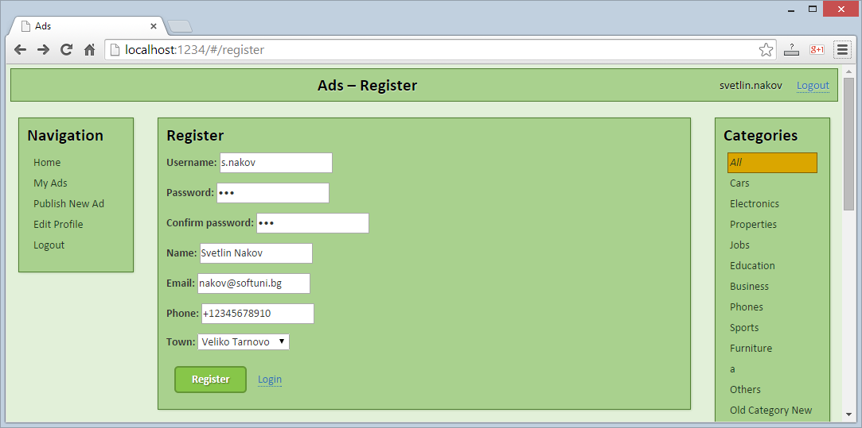

* + Check also the **incorrect user registration** functionality:

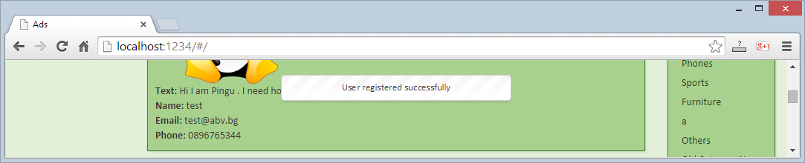

* + Check for errors at the Web browser's development console:

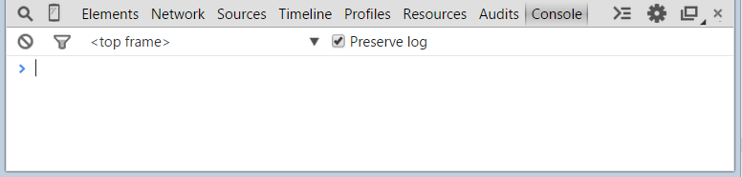

10 score